Software Requirements Specification
for
<SSE>
Version 1.0
Prepared by <Jeel Dharmesh Shah(U101114FCS172)>
<NIIT>
<21/9/2016>
Table of Contents
Table of Contents ii
Revision History ii
1. Introduction 1
1.1 Purpose 1
1.2 Document Conventions 1
1.3 Intended Audience and Reading Suggestions 1
1.4 Product Scope 1
1.5 References 1
2. Overall Description 2
2.1 Product Perspective 2
2.2 Product Functions 2
2.3 User Classes and Characteristics 2
2.4 Operating Environment 2
2.5 Design and Implementation Constraints 2
2.6 User Documentation 2
2.7 Assumptions and Dependencies 3
3. External Interface Requirements 3
3.1 User Interfaces 3
3.2 Hardware Interfaces 3
3.3 Software Interfaces 3
3.4 Communications Interfaces 3
4. System Features 4
4.1 System Feature 1 4
4.2 System Feature 2 (and so on) 4
5. Other Nonfunctional Requirements 4
5.1 Performance Requirements 4
5.2 Safety Requirements 5
5.3 Security Requirements 5
5.4 Software Quality Attributes 5
5.5 Business Rules 5
6. Other Requirements 5
Appendix A: Glossary 5
Appendix B: Analysis Models 5
Appendix C: To Be Determined List 6

Revision History
Name | Date | Reason For Changes | Version

Group Members:
- K Manoj Kumar U101114FCS
- Vinit Koshti U101114FCS
- Jagrit Kaushik U101114FCS
- Jeel Shah U101114FCS172
- Mansi Singh U101114FCS090

Introduction
Our product is based on simplifying the learning process by making search of information/books/documents easier. This is an efficient way of searching a document( by topic or keywords) rather than searching multiple documents to find the same data. It makes the search relevant and faster.

Purpose
This document provides information about the product. The product uses an unstructured search to search for information/files/documents provided as study material. The web application will be basically an interface where the user will input keyword to be searched. The software will convert scanned data in image format to text which is added in database on which elastic search will be applied for searching the input keyword.

Document Conventions
Acronyms and Abbreviations:

- SRS: Software Requirements Specification
- SDD : Software Design Description
- UC: Use Case
- SLMS: Smart Learning Management System
- LMS: Learning Management System

Intended Audience and Reading Suggestions
The target audience for the SLMS is students, teachers and administrators of various schools and universities that use e-learning platforms. The responses of users of the system, use and review the SRS document and make sure that all specifications and requirements stated are implemented and feasible. In case of modification in future, new requirements must be updated into the existing system, after an overview of this document and passing the information accurately in all aspects, the changes can be made.

Product Scope
This product is especially important and useful in the education industry. This saves the time in finding relevant information. This is a very desirous system since the user is able to retrieve the document in a managed way as well as faster. By increased efficiency of search, a student’s efficiency in his/her studies also increases. Also, the review option is very useful, as the student’s search history is saved and used the next time it is searched to bring out the outcome even faster.

References
- https://en.wikipedia.org/wiki/Tesseract_(software)
- https://bitbucket.com
- https://github.com/tesseract-ocr
- https://en.wikipedia.org/wiki/Elasticsearch
- https://standards.ieee.org/findstds/standard/830-1998.html
- https://lucene.apache.org/core/

Overall Description

Product Perspective
LMS is a software application used for management, documentation, administration, reporting and tracking of e-learning platforms. We have taken this system a step ahead in that we have incorporated new features such as keyword-searching or simply searching to give a manageable and sorted output. Thus making it a SLMS. This will be beneficiary to both students and teachers as they are both able to reach their goals efficiently. In the traditional system, the user has to search several documents most if which are irrelevant in searching for some particular data. This renewed and leveled-up system guarantees a time-saving and optimized result. In case of modification, the system makes sure that after proper review of the logs, The reviewed file is updated in the database.

Product Functions

- Increase the ease of system for making a more friendly environment for the users.
- Optimizing search(by using elastic search) .
- Providing physical security.
- Providing system for specific search options that give the convenience of finding a file depending upon its title or keywords in its data.
- Encrypting documents to ensure its safety.
- Listing all valid documents by maintenance of logs. These logs and saved history will be used for faster retrieval of previously searched data.

User Classes and Characteristics
Student: will be able to login, submit assignments, view uploaded documents, search for a specific document based on its title or data content, find their previously searched documents in the history.

Faculty: will be able to login, upload documents, review documents, search for documents, review their previously searched document.

Administrator: will be able to search in the database, add, delete or modify the database and block a particular user or give it priviledges.

Operating Environment
- The system is compatible with any web browser.

- It is independent of Operating System.

- No extra external hardware will be needed.

- It provides free access to all its users.

- A good internet speed would be recommended however it is not a necessity.

Design and Implementation Constraints
The system is designed for SSE. Open source features such as Tessearct, OCR Feeder, Elasticsearch and Apache Lucene are also used for the extended features. Many constraints fall into place during the implementation of the system such as: Implementing the system in the real working environment is a challenge; The servers must be maintained properly; The web application need to be hosted; a completely separate database is needed for log files; It requires a lot of memory.

User Documentation
The documentation will contain the following features:
- A hard copy of user manual to all the introductory users of the system.
- An online manual explain the features of the system.
- A help link to view the FAQs and information for basic functioning of the system.
- An extended contact us tab for issues that cannot be sorted by reviewing the above.

Assumptions and Dependencies
Assumptions:
- SSE uses is MySQL 5.5.31.
- It depends on Lamp Server.
- Bootstrap, Tesseract, OCR and elastic search are used

External Interface Requirements

User Interfaces
- Upload button will be available to the user to be able to upload relevant documents.
- A section dedicated to the review of documents that are uploaded.
- A section to edit and review the rating of documents.
- The user can download the required document by clicking on the download button on the screen.
- A link to the document library will be made available to the user on github that will redirect user to a webpage listing documents after implementation of search.
- User can search for documents by entering the keywords in the search bar on the webpage.
- A contact us link.

Hardware Interfaces
- TBD

Software Interfaces
It will work on every browser and it is platform independent.
- Product Smart Learing version 1.0
- Use of elastic search for simplifying and speeding-up the search between multiple documents.
- Scanned documents converted into text format using tesseract.
- Protocols used: FTP, HTTP, IP etc.
- A library including scanned documents, pdf of books and other important documents.
- Integration with SSE to provide good user friendly GUI.

Communications Interfaces
Makes use of FTP and HTTP transferring and displaying texts and files in the system. Also a page with similar functioning as forum can be implemented for the students to be able to communicate amongst themselves about their interest and queries. An alternative could be the use email service. If a document being searched for does not exist in the database, the user can be notified when the database is modified and his/her search now matches one of the available documents. For securing the database, md5 encryption can be used. Also proper penetration testing will be carried out to test the proper functionality of the system. The email service can be implemented using protocols such as IMAP, SMTP, POP…etc.

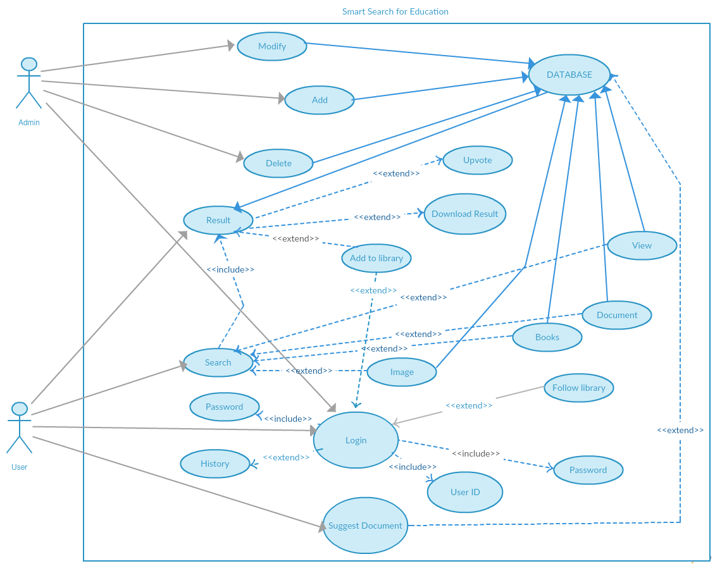
System Features

System Feature 1

Use Case Description Table
Use Case (ID) | Description
Suggest Document (UC1) | User can suggest documents
Edit Profile (UC2) | Manage User Profile
Login (UC3) | Metadata will be saved after login
User ID (UC4) | User-ID of the User
Password (UC5) | Password of the User
Follow Library (UC6) | User can follow libraries
Search (UC7) | User gives search keywords
History (UC8) | Log of user search history
Upvote (UC9) | User can upvote a document
Add to Library (UC10) | User can add documents(books/notes) to personal libraries
Result (UC11) | Search results
Download Result (UC12) | Users can download documents
Add (UC13) | Admin can insert new documents
Delete (UC14) | Admin can delete documents
Modify (UC15) | Admin can modify documents
Image (UC16) | Browse custom scanned images
View (UC17) | View documents
Document (UC18) | User can search within a document
Books (UC19) | User can search for books
Database (UC20) | System Database
Functional requirement:
Requirement name (ID) | Description
Suggest Document (UC1) | User can suggest documents
Edit Profile (UC2) | Manage User Profile
Login (UC3) | Metadata will be saved after login
User ID (UC4) | User-ID of the User
Password (UC5) | Password of the User
Follow Library (UC6) | User can follow libraries
Search (UC7) | User gives search keywords
History (UC8) | Log of user search history
Upvote (UC9) | User can upvote a document
Add to Library (UC10) | User can add documents(books/notes) to personal libraries
Result (UC11) | Search results
Download Result (UC12) | Users can download documents
Add (UC13) | Admin can insert new documents
Delete (UC14) | Admin can delete documents
Modify (UC15) | Admin can modify documents
Image (UC16) | Browse custom scanned images
View (UC17) | View documents
Document (UC18) | User can search within a document
Books (UC19) | User can search for books
Database (UC20) | System Database

Performance Requirements
- Query should be found in any file format may it be doc, pdf, png, jpg…etc.
- As a large amount of data is concerned, suitable place for data storage and data structures must be chosen so as to provide optimal retrieval speed.
- Since all the data is stored at one place, the security of the data must also be taken under consideration.
- The processing speed of server and devices must be more in order to get efficient results.
- Timely maintenance and reviewing of logs is necessary.
- Since this is an extended version of LMS, it should take a reduced time span for search processing.
- It should provide an authenticated login for all its users.
- The Admin must have the authority to modify the database as well as block unwanted users from the system whenever required.

Safety Requirements and Security Requirements
As a lot of data is involved, physical security must be kept into mind. The server system must be kept in an enclosed room which cannot be accessed without permission; CCTV surveillance can help record and physical intrusion activity. Logically, security protection would be needed in password protection where md5 can be used. Use of protocols such as IPS and IDS may also be helpful. Documents that do not have access permissions for all users may better remain encrypted while transferred or otherwise. Some basic measures should also be kept in mind such as enabling the firewall at all times and using auto-update version operating systems.

Software Quality Attributes
The following are the quality attributes for the software:
- SLMS has java applet making it platform independent and thus portable.
- Since this is an extended version of the widely used traditional LMS, the time and cost of training will be saved.
- The system is made reliable and ensures correctness of data due to application of penetration testing.
- It is suitable and available to a wide range of community such as: education institutes, large organizations, academician as well as to open source community.
- Ensures efficiency by performing checks on the system to make sure it is providing the right tools for all its stated features.
- An efficient algorithm in use to ensure its speed.
- User-friendly interface for ease of use and comprehension.

Business Rules
The task is divided within the group for ensuring the success of product:

- Developer is assigned the task of building the web application.
- The web application goes through a penetration testing activity carried out by penetration tester for identifying the loopholes in the system if any.
- The Marketing team is responsible for spreading the awareness about the product to various institutes and community.
- Advertisement team works in the same line as Marketing team to be able to deliver the message to ever individual.

Other Requirements
Requirements except the ones listed above TBD
Appendix A: Glossary
- SRS: Software Requirements Specification
- SDD : Software Design Description
- UC: Use Case
- SLMS: Smart Learning Management System
- LMS: Learning Management System
- TBD: To Be Determined
Appendix C: To Be Determined List
- Section 3.2 (Hardware interfaces)
- Section 6 (Other requirements)

